GOVERNMENT COLLEGE OF ENGINEERING-THANJAVUR

ASSIGNMENT-3

NAME : A.MANIBALAN

REG.NO : 822721104027

YEAR : III

DEPT : COMPUTER SCIENCE AND ENGINEERING

SUBJECT CODE : CCS375

SUBJECT NAME : WEB TECHNOLOGIES

DATE : 29-02-2024

**PROGRAM:**

<!DOCTYPE html>

<html lang="en">

<head>

<meta charset="UTF-8">

<meta name="viewport" content="width=device-width, initial-scale=1.0">

<title>Document</title>

<link rel="stylesheet" href="front.css">

</head>

<body>

<table border="1" width="100%" height="600px">

<tr>

<td width="30%">

<div class="left" align="center">

<a target="programs" href="palindrome.html">1.PALINDROME</a><br>

<a target="programs" href="prime.html">2.PRIME</a><br>

<a target="programs" href="listprime.html">3.LIST OF PRIME NUMBERS</a><br>

<a target="programs" href="minmax.html">4.MIN AND MAX IN ARRAY</a><br>

<a target="programs" href="fibonacci.html">5.FIBBONACCI SERIES</a><br>

<a target="programs" href="unique.html".html">6.UNIQUE ELEMENT IN AN ARRAY</a><br>

<a target="programs" href="titlecase.html">7.TITLE CASE</a><br>

<a target="programs" href="merge.html">8.MERGE THE SORTED ARRAY</a><br>

<a target="programs" href="nested.html">9.NESTED ARRAY</a>

</div>

</td>

<td width="70%">

<iframe src="" name="programs" frameborder="4" height="600px" width="100%"></iframe>

</td>

</tr>

</table>

</body>

</html>

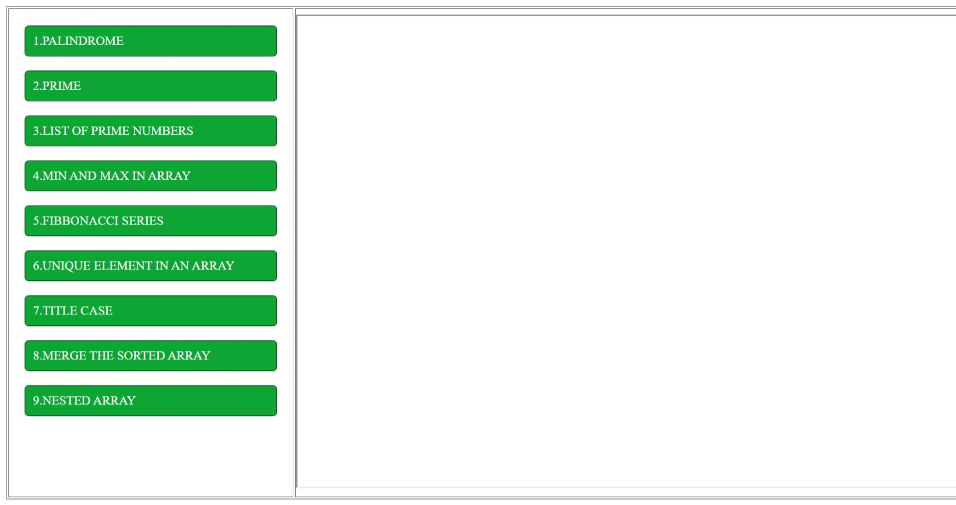

**1. Write a JavaScript function to check if a given string is a palindrome.**

<html>

<head>

<title>PALINDROME</title>

<link rel="stylesheet" href="front.css">

<script>

function check()

{

var t1=document.getElementById("input").value;

let str="";

for(var i=t1.length;i>=0;i--)

{

str=str+t1.charAt(i);

}

if(t1===str)

{

document.getElementById("result").value="YES,THAT'S PALINDROME";

}

else

{

document.getElementById("result").value="OOPs THAT'S NOT A PALINDROME";

}

}

</script>

</head>

<body>

<div class="bor" align="center" >

<form>

<table class="table" border="0" cellpadding="4px" width="100%">

<caption><h1>PALINDROME OR NOT</h1></caption>

<tr>

<td><label>ENTER THE WORD:</label></td>

<td><input type="text" id="input"></td>

</tr>

<tr >

<td colspan="2"align="center">

<input class="button" type="button" value="CHECK" onclick="check()">

</td>

</tr>

<tr>

<td>SO THE ABOVE TEXTED WORD IS:</td>

<td><input type="text" id="result"></td>

</tr>

</table>

</form>

</div>

</body>

</html>

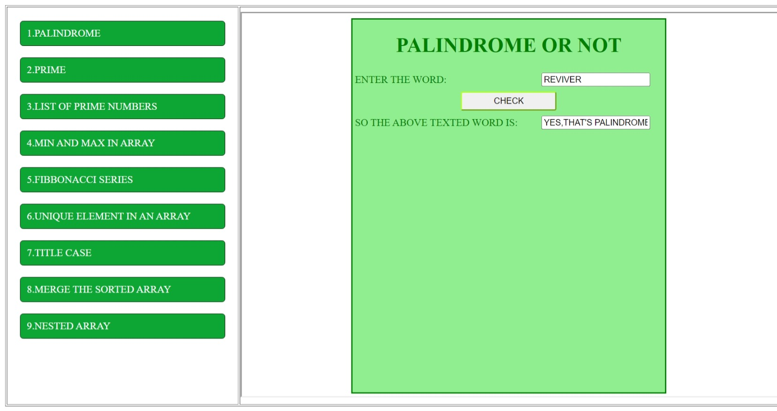

**2. Write a JavaScript function to check if a given number is prime.**

<html>

<head>

<title>PRIME NUMBER</title>

<link rel="stylesheet" href="front.css">

<script>

function check()

{

var t1=document.getElementById("input").value;

var n=0;

if(t1>0)

{

for(var i=1;i<=t1;i++)

{

if(t1%i===0)

n++;

}

if(n<=2)

{

document.getElementById("output").value="PRIME NUMBER";

}

else

{

document.getElementById("output").value="NOT A PRIME NUMBER";

}

}

else if(t1==0)

alert("ZERO is not a prime and not a composite number");

else

{

alert("INVALID SYNTAX");

}

}

</script>

</head>

<body>

<div class="bor" align="center" >

<form>

<table class="table" border="0" cellpadding="4px" width="500px">

<caption><h1>PRIME OR NOT</h1></caption>

<tr>

<td><label>ENTER A NUMBER:</label></td>

<td><input type="text" id="input"></td>

</tr>

<tr>

<td colspan="2"align="center"><input class="button" type="button" id="q" value="CHECK" onclick="check()"></td>

</tr>

<tr>

<td><label>SO THE ABOVE NUMBER IS:</label></td>

<td><input type="text" id="output"></td>

</tr>

</table>

</form>

</div>

</body>

</html>

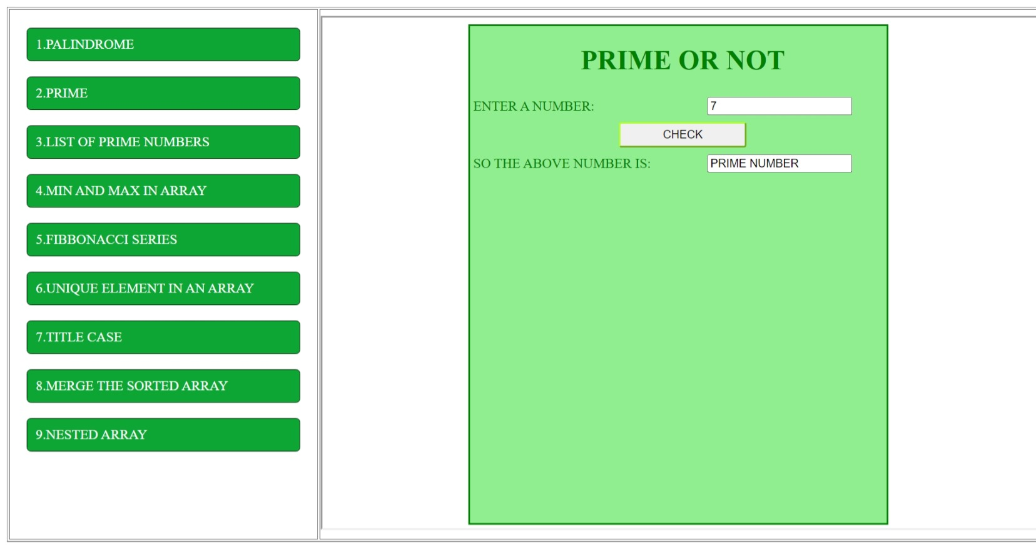

**3. Write a java script function to display the list of prime numbers from 1 to n.**

<html>

<head>

<title>LIST OF PRIME NUMBERS</title>

<link rel="stylesheet" href="front.css">

<script>

function show()

{

var arr=[];

var n=document.getElementById("input").value;

var flag=0;

var lv=0;

if(n>0)

{

for(var i=1;i<=n;i++)

{

for( var j=1;j<=i;j++)

{

if(i%j==0)

flag++;

}

if(i!=1 && flag<=2)

{

arr[lv++]=i;

}

flag=0;

}

}

else

alert("erroer");

document.getElementById("output").value=arr;

}

</script>

</head>

<body>

<div class="bor" align="center" >

<form>

<table class="table" border="0" cellpadding="4px" width="500px">

<caption><h1>PRIME NUMBERS</h1></caption>

<tr>

<td><label>ENTER A NUMBER UP:</label></td>

<td><input type="text" id="input"> </td>

</tr>

<tr>

<td colspan="2" align="center"><input class="button" type="button" onclick="show()" value="LIST"></td>

</tr>

<tr>

<td>RESULT</td>

<td> <input type="text" id="output"></td>

</tr>

</table>

</form>

</div>

</body>

</html>

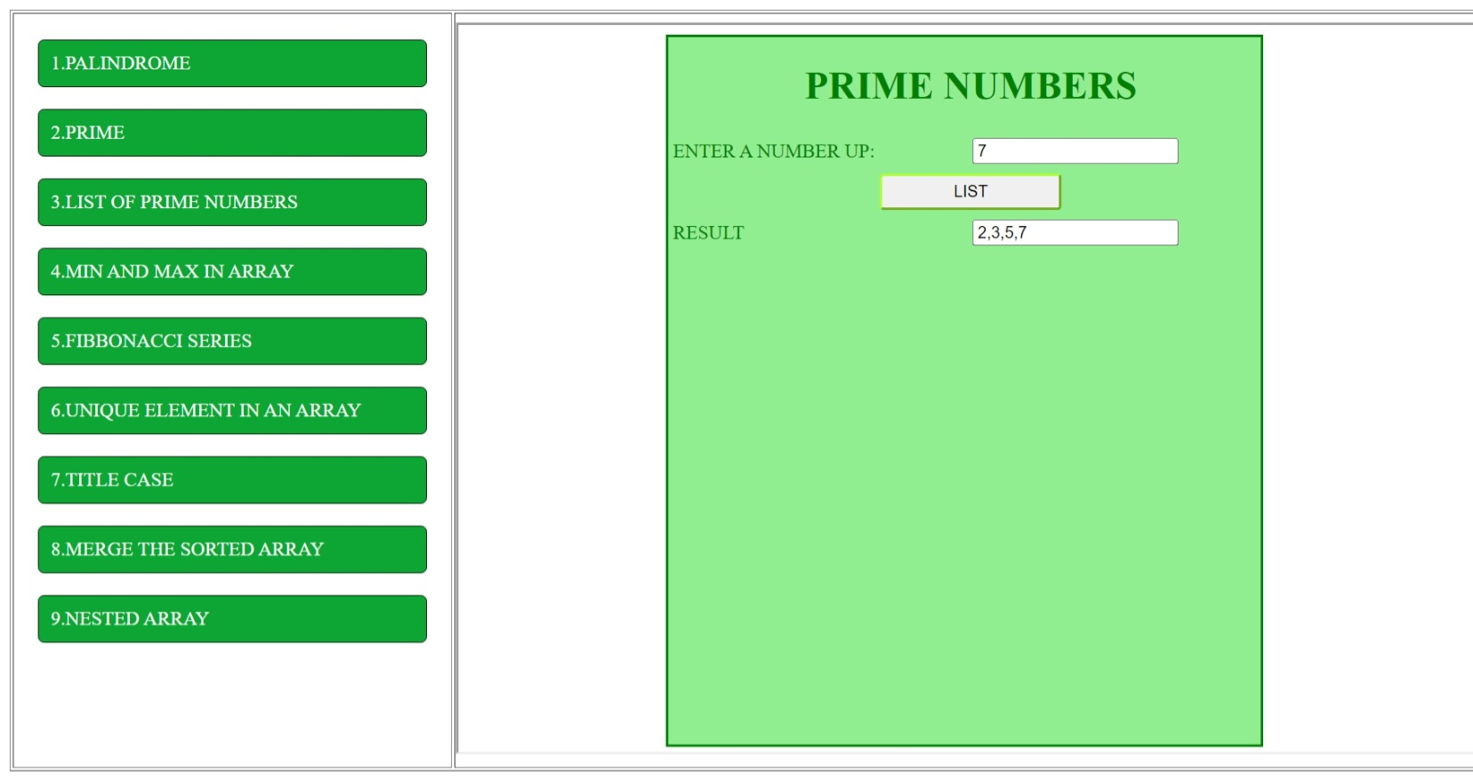

**4. Given an array of numbers, write a function to find the largest and smallest numbers in the array.**

<html>

<head>

<title>LARGEST AND SMALLEST NUMBERS</title>

<link rel="stylesheet" href="front.css">

<script>

function find()

{

var arr=new Array();

var n=document.getElementById("input").value;

for(var i=0;i<n;i++)

{

arr[i]=Number(window.prompt("Enter the Array Element "+(i+1)));

}

for(var i=0;i<n;i++)

{

for(var j=0;j<n;j++)

{

if(arr[j]>arr[j+1])

{

temp=arr[j];

arr[j]=arr[j+1];

arr[j+1]=temp;

}

}

}

alert(arr);

document.getElementById("output max").value=arr[arr.length-1];

document.getElementById("output min").value=arr[0];

}

</script>

</head>

<body>

<div class="bor" align="center" >

<form>

<table class="table" border="0" cellpadding="4px" width="500px">

<caption><h1>FIND LARGEST AND SMALLEST NUMBER</h1></caption>

<tr>

<td>ENTER THE NUMBER</td>

<td><input type="text" id="input"></td>

</tr>

<tr>

<td colspan="2" align="center"><input class="button" type="button" onclick="find()" value="FIND"></td>

</tr>

<tr>

<td>LARGEST NUMBER</td>

<td><input type="text" id="output max"></td>

</tr>

<tr>

<td>SMALLEST NUMBER</td>

<td><input type="text" id="output min"></td>

</tr>

</table>

</form>

</div>

</body>

</html>

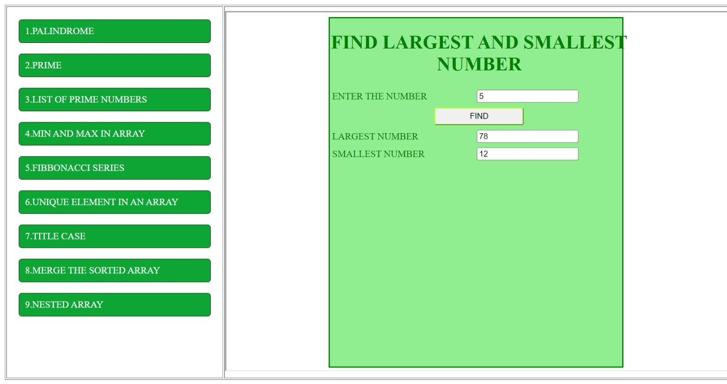

**5. Write a JavaScript function that returns the Fibonacci sequence up to a given number of**

**terms.**

<html>

<head>

<title>FIBBONACCI SERIES</title>

<link rel="stylesheet" href="front.css">

</head>

<body>

<div class="bor" align="center" >

<form>

<table class="table" border="0" cellpadding="4px" width="500px">

<caption><h1><h1>FIBONOCCI SERIES</h1></h1></caption>

<tr>

<td>ENTER THE NUMBER</td>

<td><input type="text" id="input"></td>

</tr>

<tr>

<td colspan="2" align="center"> <input class="button" type="button" onclick="fibbo()" value="FIBBO SERIES">

</tr>

<tr>

<td>THE FIBBONACCI SERIES IS:</td>

<td > <input type="text" id="output"></td>

</tr>

</table>

</form>

</div>

<script>

function fibbo()

{

var n=document.getElementById("input").value;

var t1=0,t2=1;

var t3;

var arr=new Array();

if(n>0)

{

for(var i=0;i<n;i++)

{

arr.push(t2);

t3=t1+t2;

t1=t2;

t2=t3;

}

document.getElementById("output").value=arr;

}

else

alert("Give me a Number");

}

</script>

</body>

</html>

<html>

<head>

<title>FIBBONACCI SERIES</title>

<link rel="stylesheet" href="front.css">

</head>

<body>

<div class="bor" align="center" >

<form>

<table class="table" border="0" cellpadding="4px" width="500px">

<caption><h1><h1>FIBONOCCI SERIES</h1></h1></caption>

<tr>

<td>ENTER THE NUMBER</td>

<td><input type="text" id="input"></td>

</tr>

<tr>

<td colspan="2" align="center"> <input class="button" type="button" onclick="fibbo()" value="FIBBO SERIES">

</tr>

<tr>

<td>THE FIBBONACCI SERIES IS:</td>

<td > <input type="text" id="output"></td>

</tr>

</table>

</form>

</div>

<script>

function fibbo()

{

var n=document.getElementById("input").value;

var t1=0,t2=1;

var t3;

var arr=new Array();

if(n>0)

{

for(var i=0;i<n;i++)

{

arr.push(t2);

t3=t1+t2;

t1=t2;

t2=t3;

}

document.getElementById("output").value=arr;

}

else

alert("Give me a Number");

}

</script>

</body>

</html>

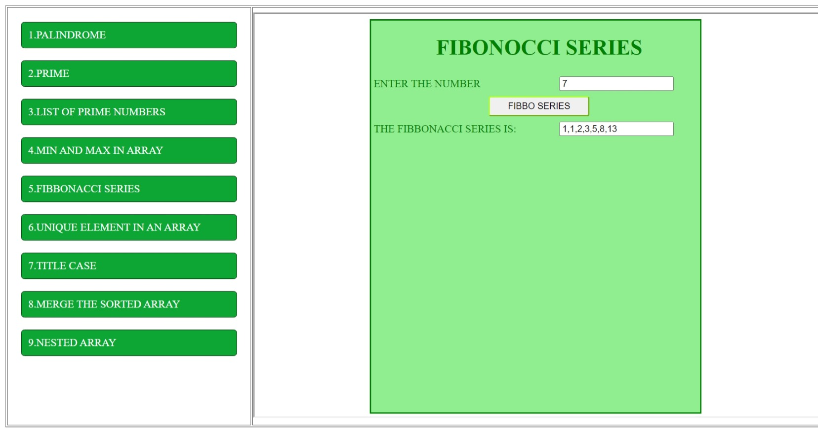

**6. Write a function that takes an array of integers as input and returns a new array with only the unique elements.**

<html>

<head>

<title>UNIQUE</title>

<link rel="stylesheet" href="front.css">

<script>

function unique()

{

var arr1=new Array();

var arr2=new Array();

var n=document.getElementById("input").value;

var temp=0;

for(var i=0;i<n;i++)

{

arr1[i]=parseInt(window.prompt("enter the value"+(i+1)));

}

for(var i=0;i<n;i++)

{

if(i==0)

arr2.push(arr1[i]);

for(j=0;j<arr2.length;j++)

{

if(arr1[i]==arr2[j])

temp++

}

if(temp==0)

arr2.push(arr1[i]);

temp=0;

}

document.getElementById("output").value=arr2;

}

</script>

</head>

<body>

<div class="bor" align="center" >

<form>

<table class="table" border="0" cellpadding="4px" width="500px">

<caption> <h1>UNIQUE ELEMENTS</h1></caption>

<tr>

<td><label for="">ENTER THE NUMBER:</label></td>

<td> <input type="text" id="input"></td>

</tr>

<tr>

<td colspan="2" align="center"> <input class="BUTTON" type="button" onclick="unique()" value="CLICK">

</tr>

<tr>

<td> <label for="">UNIQUE NO IS:</label></td>

<td > <input type="text" id="output"></td>

</tr>

</table>

</form>

</div>

</body>

</html>4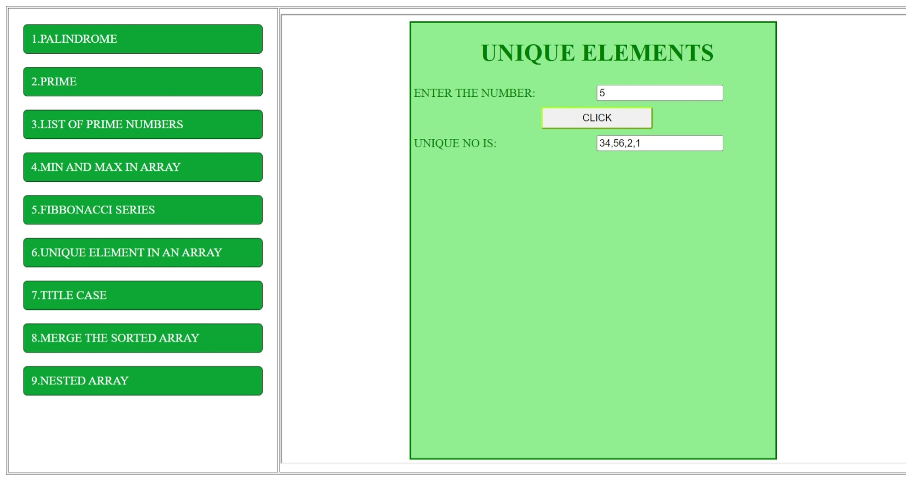

**7. Write a JavaScript program to convert a string to title case.**

<html>

<head>

<title>title case</title>

<link rel="stylesheet" href="front.css">

<script>

function tcase()

{

var n;

var str=document.getElementById("input").value;

n=str.length;

var t1;

var t2;

var string="";

t1=0;

for(var i=0;i<n;i++)

{

if(str.charAt(i)==" ")

{

t1=0;

}

else if(t1==0)

{

string=string+(str.charAt(i).toUpperCase());

t1++;

continue;

}

string=string+str.charAt(i);

}

document.getElementById("output").value=string;

}

</script>

</head>

<body>

<div class="bor" align="center" >

<form>

<table class="table" border="0" cellpadding="4px" width="500px">

<caption> <h1>TITLE CASE</h1></caption>

<tr>

<td><label for="">ENTER THE WORDS:</label></td>

<td><input type="text" id="input"></td>

</tr>

<tr>

<td colspan="2" align="center"> <input class="button" type="button" id="p" onclick="tcase()" value="enter">

</tr>

<tr> <td> <label for="">Title Case Word Is:</label></td>

<td > <input type="text" id="output"></td>

</tr>

</table>

</form>

</div

<form>

</form>

</body>

</html>

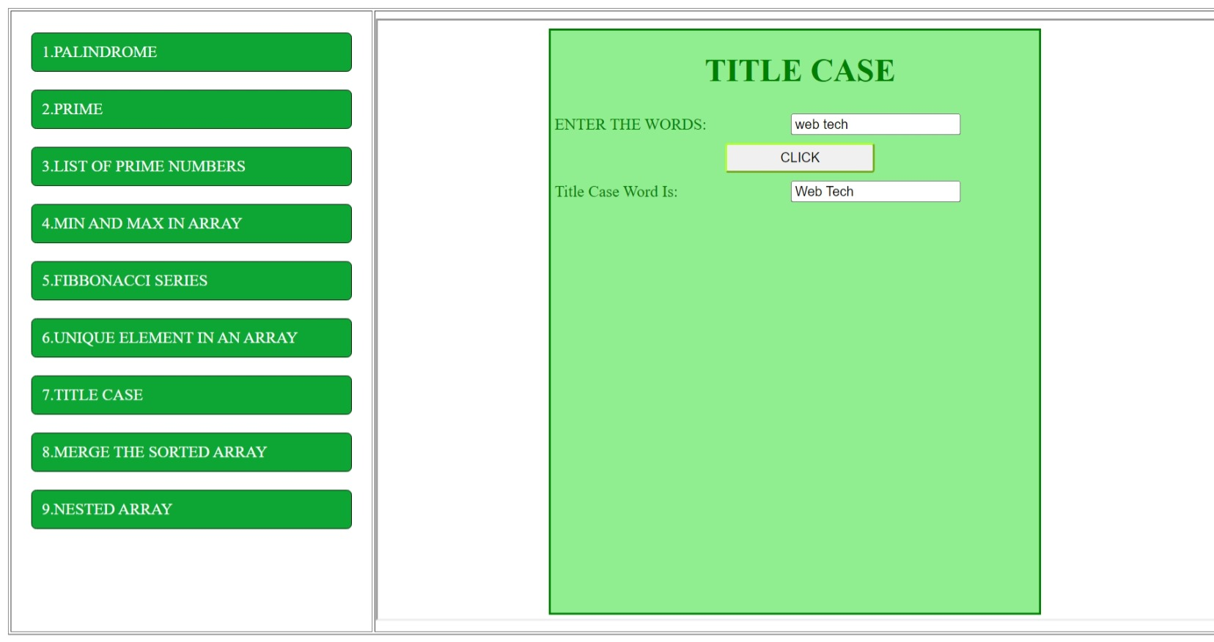

**8. Implement a function that takes two sorted arrays and merges them into a single sorted array without using any built-in sorting functions.**

<html>

<head>

<title>Merge Sorted Array</title>

<link rel="stylesheet" href="front.css">

<script>

function merge()

{

var arr1=new Array();

var arr2=new Array();

// var n=document.getElementById("input").value;

var temp=0;

var num1=parseInt(window.prompt("Array1"));

for(var i=0;i<num1;i++)

arr1[i]=parseInt(window.prompt("Enter the Array Element for 1st Array"));

for(var i=0;i<num1;i++)

{

for(var j=0;j<num1;j++)

{

if(arr1[j]>arr1[j+1])

{

temp=arr1[j];

arr1[j]=arr1[j+1];

arr1[j+1]=temp;

}

}

}

var num2=parseInt(window.prompt("Array 2"));

for(var i=0;i<num2;i++)

arr2[i]=parseInt(window.prompt("Enter the Array Element for 2nd Array"));

for(var i=0;i<num2;i++)

{

for(var j=0;j<num2;j++)

{

if(arr2[j]>arr2[j+1])

{

temp=arr2[j];

arr2[j]=arr2[j+1];

arr2[j+1]=temp;

}

}

}

var mergearray=new Array();

var temp2=0;

var i=0;j=0;

while((i<num1) &&(j<num2))

{

if(arr1[i]<arr2[j])

mergearray[temp2++]=arr1[i++];

else

mergearray[temp2++]=arr2[j++];

}

while(i<num1)

mergearray[temp2++]=arr1[i++];

while(j<num2)

mergearray[temp2++]=arr2[j++];

alert(mergearray);

document.getElementById("output").value=mergearray;

}

</script>

</head>

<body>

<div class="bor" align="center" >

<form>

<table class="table" border="0" cellpadding="4px" width="500px">

<caption> <h1>MERGE THE SORTED ARRAYS</h1></caption>

<tr>

<td colspan="2" align="center"> <input type="text" id="input" placeholder="only 2 array"></td>

</tr>

<tr>

<td colspan="2" align="center"> <input class="button" type="button" onclick="merge()" value="Press Here To Input The Array Values">

</tr>

<tr>

<td> <label for="">Merged Sorted Array Is:</label></td>

<td > <input type="text" id="output"></td>

</tr>

</table>

</form>

</div>

</body>

</html>

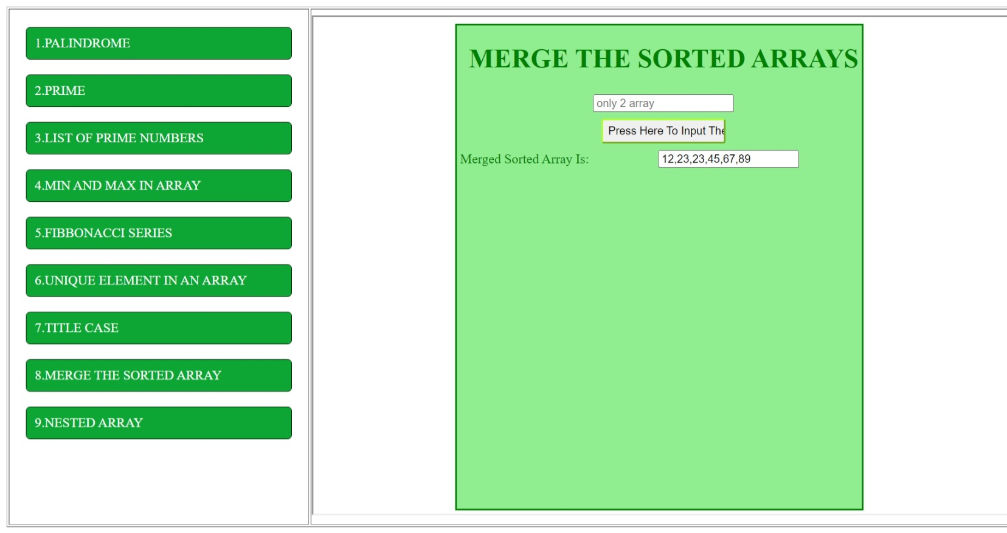

**9. Implement a function that flattens a nested array in JavaScript, converting it into a single level array.**

<html>

<head>

<title>Nested Array</title>

<link rel="stylesheet" href="front.css">

</head>

<body>

<div class="bor" align="center" >

<form>

<table class="table" border="0" cellpadding="4px" width="100%">

<caption><h1>NESTED ARRAYS</h1></caption>

<tr align="center">

<td><label>ROW SIZE:</label></td>

<td><input type="text" id="input"></td>

</tr>

<tr >

<td colspan="2"align="center">

<input class="button" type="button" onclick="nest()" value="INITIALIZE">

</td>

</tr>

<tr>

<td>

<div align="center" id="result1">

<H3>TWO DIMENTIONAL ARRAY</H3>

</div>

</td>

<td>

<div align="center" id="result2">

<H3>TWO DIMENTIONAL ARRAY</H3>

</div>

</td>

</tr>

</table>

</form>

</div>

<script>

function nest()

{

var row_size=document.getElementById("input").value;

var n;

var flag=0;

var arr1=new Array();

var arr2=new Array();

for(var i=0;i<row_size;i++)

{

arr1[i]=[];

n=window.prompt("NUMBER OF COLUMN VALUES IN ROW :"+(i));

for(var j=0;j<n;j++)

arr1[i].push(window.prompt("ENTER THE VALUEES :"+(j+1)));

}

alert("hi");

for(var i=0;i<row_size;i++)

{

document.getElementById("result1").innerHTML=

document.getElementById("result1").innerHTML+"[";

for(var j=0;j<arr1[i].length;j++){

document.getElementById("result1").innerHTML=

document.getElementById("result1").innerHTML+arr1[i][j]+"&nbsp;&nbsp;";

}

document.getElementById("result1").innerHTML=

document.getElementById("result1").innerHTML+"]" +"<br>";

}

for(var i=0;i<row_size;i++)

{

for(var j=0;j<arr1[i].length;j++)

arr2[flag++]=arr1[i][j];

}

document.getElementById("result2").innerHTML="["+arr2+"]" ;

}

</script>

</body>

</html>

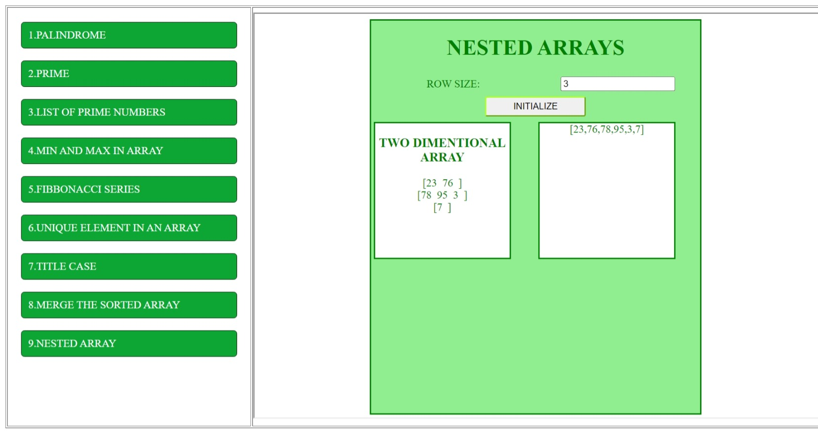

**Css:**

.left{

/* border: 2px solid #000000; */

margin-top: 20px;

width: 100%;

height:600px;

}

.left a{

border: 1px solid rgb(10, 22, 10);

padding: 10px 10px 10px 10px;

display: flex;

text-decoration: none;

width: 300px;

background-color: rgb(13, 165, 51);

color: white;

border-radius: 5px;

}

.bor{

border: 2px solid green;

align-items: center;

height: 100%;

width: 60%;

margin-left: 20%;

background-color: lightgreen;

}

.table{

border-collapse: collapse;

color: green;

}

.button{

border-color: greenyellow;

width: 150px;

height: 30px;

border-radius: 3px;

}

#result1{

border: 2px solid green;

background-color: white;

color: green;

width: 200px;

height: 200px;

}

#result2{

border: 2px solid green;

background-color: white;

color: green;

width: 200px;

height: 200px;

}